**Creating Restful Webservice from Pattern**

Step 1: Create a New Java Web Application Project

1. Open NetBeans IDE.
2. Click on "File" > "New Project..."
3. Choose "Java Web" > "Web Application" and click "Next."

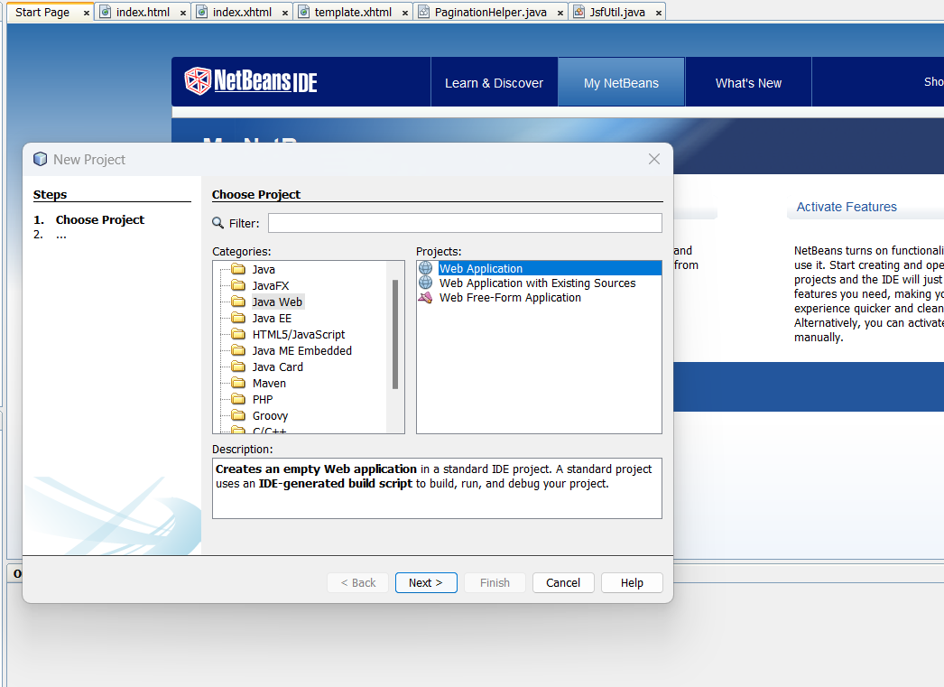

1. Give your project a name (e.g., "RestfulWebServicePattern") and choose a location. Click

"Next."

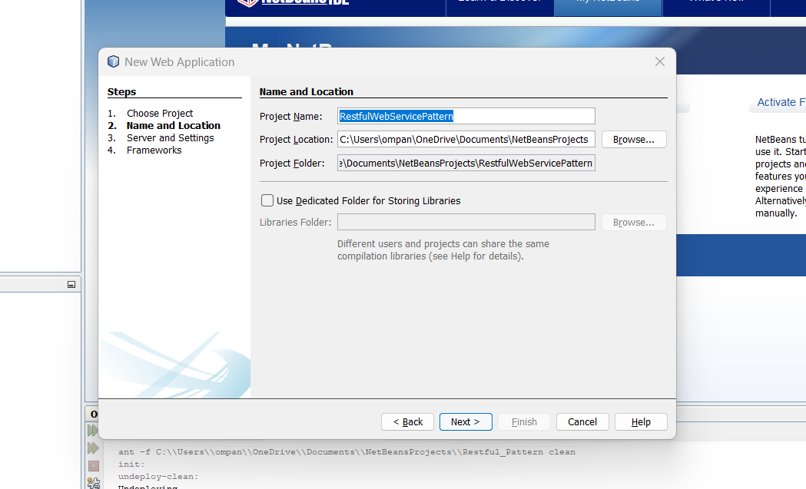

1. Select "JavaServer Faces" as the framework and "GlassFish" as the server. Click "Finish."

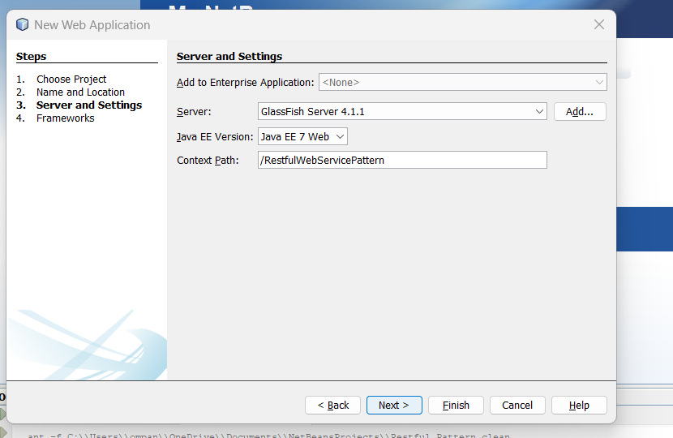

Step 2: Create a New RESTful Web Service

1. Right-click on the Source Packages folder in your project.
2. Choose New -> Other.
3. In the Categories panel, select Java Web and then choose RESTful Web Services from Patterns.
4. Click Next.

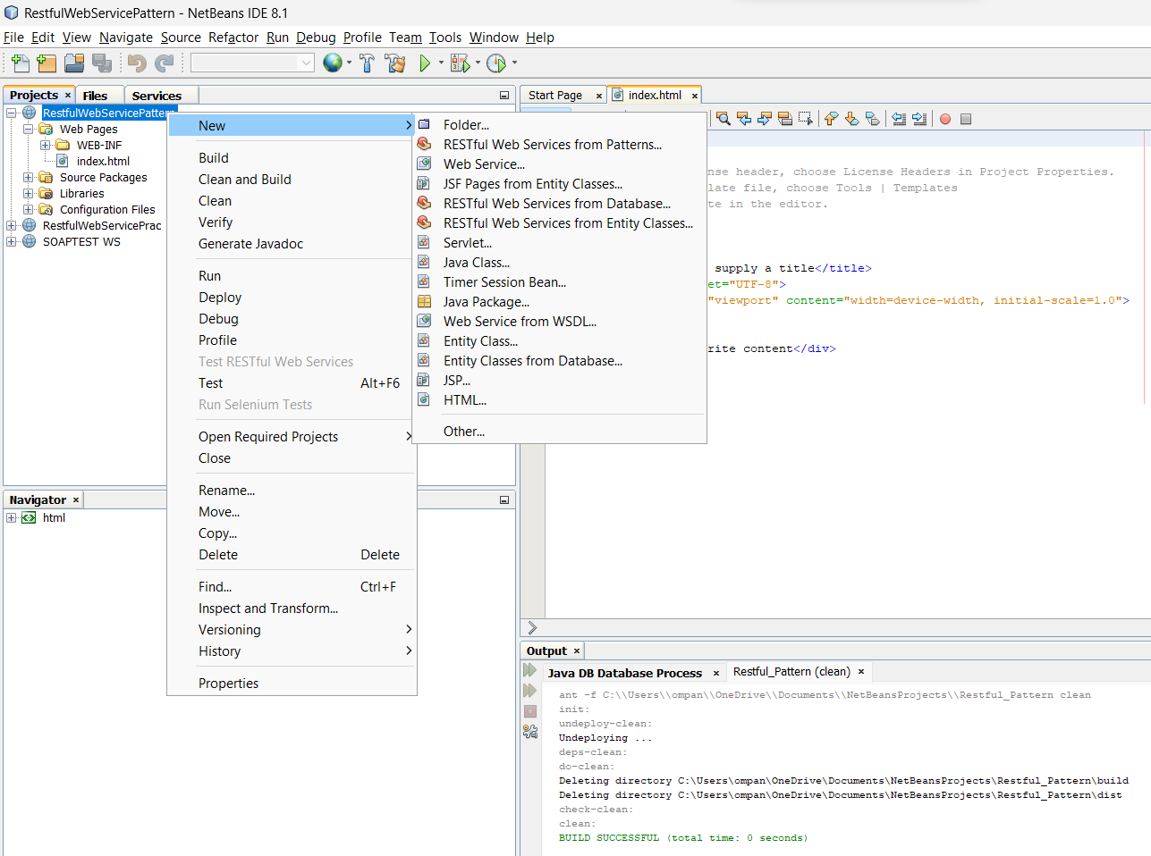

5.Click Next,

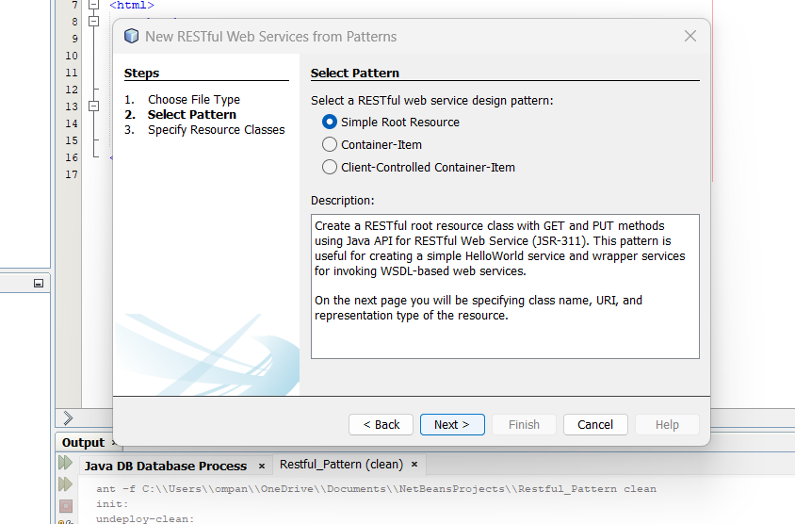

Step 3: New Restful Web Service from Pattern

1. Fill resource package name (com.pattern.xyzom)
2. Add MIME Type – text/html

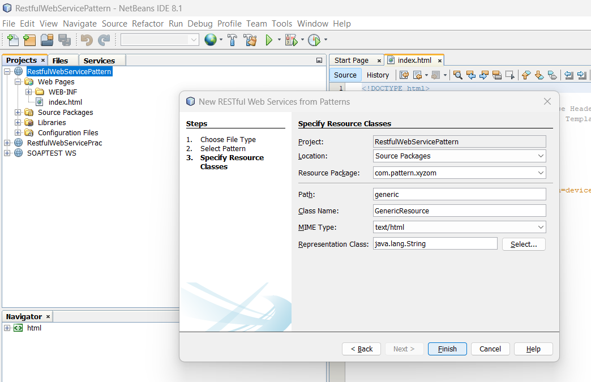

Step 4: In Genic .java using –

@GET method looks correct for returning HTML content that includes the current time.

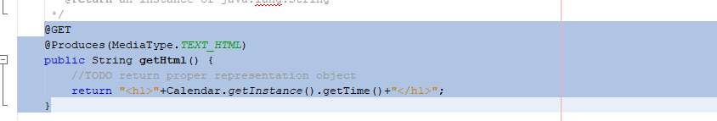

Step 5: Deploy your WebService

1. Right-click on your project in the "Projects" pane.
2. Select "Clean and Build."
3. Right-click on your project again.
4. Select "Deploy" to deploy the project to the GlassFish server.

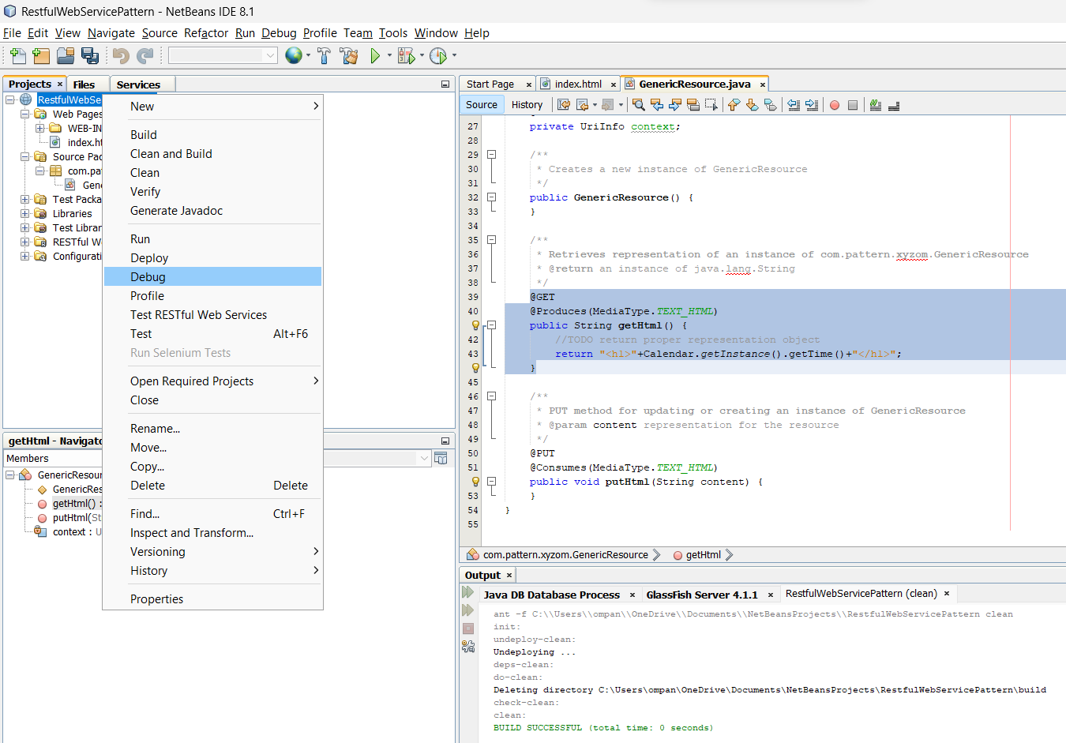

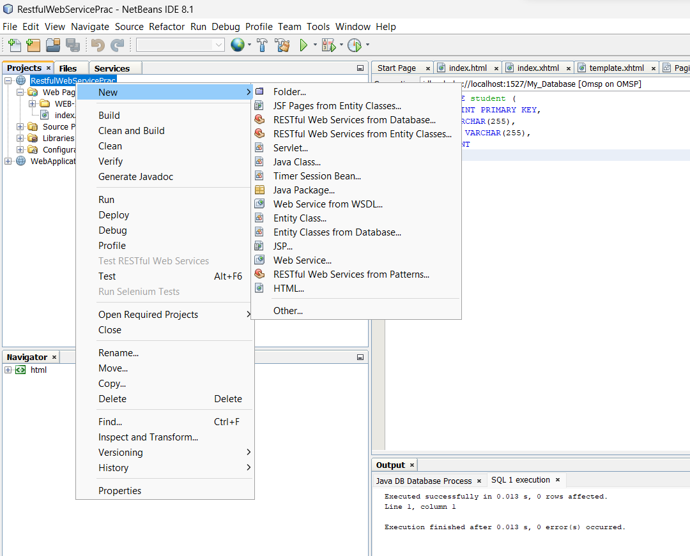

Step 6: Test your webservice

